**JDBC – introduction**

|  |  |
| --- | --- |
| **Closing normally** | **Closing by default** |
| **package** com.company;  **import** java.sql.Connection; **import** java.sql.DriverManager; **import** java.sql.Statement;  **public class** Main {   **public static void** main(String[] args) {  **try**(){  Connection con = DriverManager.*getConnection*(**"jdbc:sqlite:C:\\Users\\Soham Roy\\IdeaProjects\\testdb2\\fuckin.db"**);  Statement statement = con.createStatement();  statement.execute(**"create table fox(name text, phone integer, email text)"**);  statement.close();  con.close();  } **catch** (Exception e) {  System.***out***.println(**"message : "** + e.getMessage());  }  } } | **package** com.company;  **import** java.sql.Connection; **import** java.sql.DriverManager; **import** java.sql.Statement;  **public class** Main {   **public static void** main(String[] args) {  **try**(Connection con = DriverManager.*getConnection*(**"jdbc:sqlite:C:\\Users\\Soham Roy\\IdeaProjects\\testdb2\\fuckin1.db"**);  Statement statement = con.createStatement()){  statement.execute(**"create table fox(name text, phone integer, email text)"**);  } **catch** (Exception e) {  System.***out***.println(**"message : "** + e.getMessage());  }  } } |

If you execute any of the programme second time, you gonna get an ERROR MESSAGE 🡪 **message : [SQLITE_ERROR] SQL error or missing database (table fox already exists)**

**SOLUTION:**

|  |
| --- |
| **package** com.company;  **import** java.sql.Connection; **import** java.sql.DriverManager; **import** java.sql.Statement;  **public class** Main {   **public static void** main(String[] args) {  **try**{  Connection con = DriverManager.*getConnection*(**"jdbc:sqlite:C:\\Users\\Soham Roy\\IdeaProjects\\testdb2\\fuckin.db"**);  Statement statement = con.createStatement();  statement.execute(**"create table IF NOT EXISTS fox(name text, phone integer, email text)"**);  statement.close();  con.close();  } **catch** (Exception e) {  System.***out***.println(**"message : "** + e.getMessage());  }  } } |

**Inserting value into the database**

|  |
| --- |
| **package** com.company;  **import** java.sql.Connection; **import** java.sql.DriverManager; **import** java.sql.Statement;  **public class** Main {  **public static void** main(String[] args) {  **try**{  Connection con = DriverManager.*getConnection*(**"jdbc:sqlite:C:\\Users\\Soham Roy\\IdeaProjects\\testdb2\\fuckin.db"**);  Statement statement = con.createStatement();  statement.execute(**"create table IF NOT EXISTS fox(name text, phone integer, email text)"**);  statement.execute(**"insert into fox (name, phone, email) values ('Ivy', 7485965214, 'ivy@gmail.com')"**);  statement.close();  con.close();  } **catch** (Exception e) {  System.***out***.println(**"message : "** + e.getMessage());  }  } } |

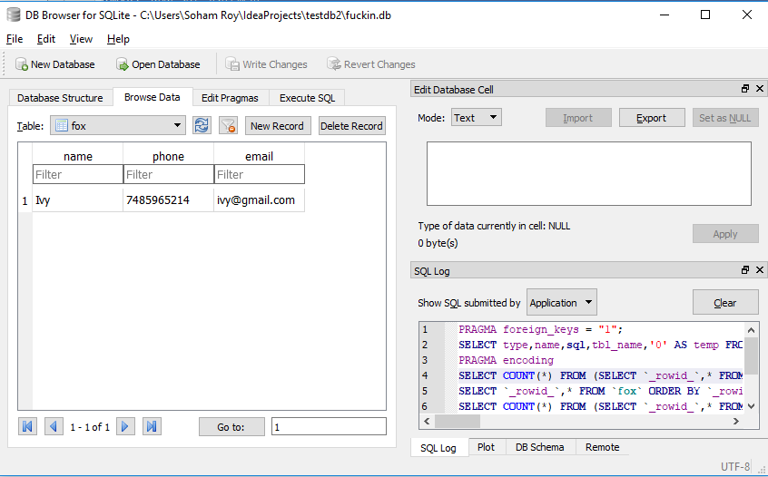

**package** com.company;  
  
**import** java.sql.Connection;  
**import** java.sql.DriverManager;  
**import** java.sql.Statement;  
  
**public class** Main {  
  
 **public static void** main(String[] args) {  
 **try**{  
 Connection con = DriverManager.*getConnection*(**"jdbc:sqlite:C:\\Users\\Soham Roy\\IdeaProjects\\testdb2\\fuckin.db"**);  
 *// con.setAutoCommit(false); RESISTS TO ADD THE VALUES IN THE TABLE*

Statement statement = con.createStatement();  
 statement.execute(**"create table IF NOT EXISTS fox(name text, phone integer, email text)"**);  
 statement.execute(**"insert into fox (name, phone, email) values ('Jime', 74124579361, 'jime@gmail.com')"**);  
 statement.execute(**"insert into fox (name, phone, email) values ('Arya', 002121313, 'arys@gmail.com')"**);  
 statement.execute(**"insert into fox (name, phone, email) values ('Deneries', 1568745896, 'clark@gmail.com')"**);  
 statement.close();  
 con.close();  
 } **catch** (Exception e) {  
 System.***out***.println(**"message : "** + e.getMessage());  
 }  
 }  
}

